# MIS 275 - Lab 2

You will need to complete this lab by using ERD Development Tool. Use your textbook and this week’s lecture as resources for help in completing the lab. Once you have completed the assignment then upload it to Blackboard. Save your document with the following naming convention:

* Course_Lab Number_First Initial Last Name (Example: MIS275_Lab2_LStewart.docx)

Complete Problems 1-11 From Cengage Pg. 33

Answer the exercises below. Number each answer. You don’t need to write the question, just provide the answer. For exercise 11, provide a screen print of your spreadsheet along with your answer.

1. There are 7 records each with 5 fields per.

2. The problem is that there is no field that is just the city, instead it’s a full address. This would not allow the search or organization of data by city.

3. You would need to split the data into separate fields so that the search could be organized. There would need to be more fields to fill in with last name, area code, city, state, and zip code.

4. There are multiple records that have the same information, such as the same address. Which would cause problems when separating the data by address.

5. There are the same project numbers, name, job code, and phone numbers.

6. I think the data should be separated into multiple files, based on each employee, instead of having all the employees in one file with recurring data.

7. The data is a collection of employee data for different jobs that they went on. There is the project number, name, employee number, hours, phone.

8. There needs to be multiple files per each employee.

9. First the initial isn’t necessary, also there should be another field for days.

10. Then you wouldn’t have data for those records?

11. a. 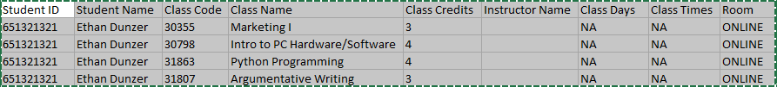

b.

c. There is no need for the student name and ID.

Complete Problems 16 and 17 From Cengage Pg. 69

For question 16 number and paste the five screen prints of your diagrams here.

a. 

b.



c.

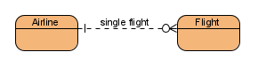

d.

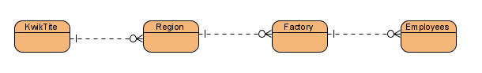

e.

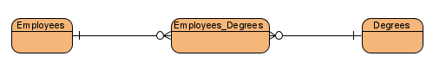

For question 17 describe the business rules here.

There are multiple theaters that play movies and there are multiple movies that play in multiple theaters. For every movie there are reviews that write a review for it.

When you are finished, upload this Word document with your answers to the designated link in Blackboard.